How Was the Learning?
Check One:
- I got It!
- I need more practice
- I need more help
Circle the emoji that best explains how you feel about the learning from this lesson.
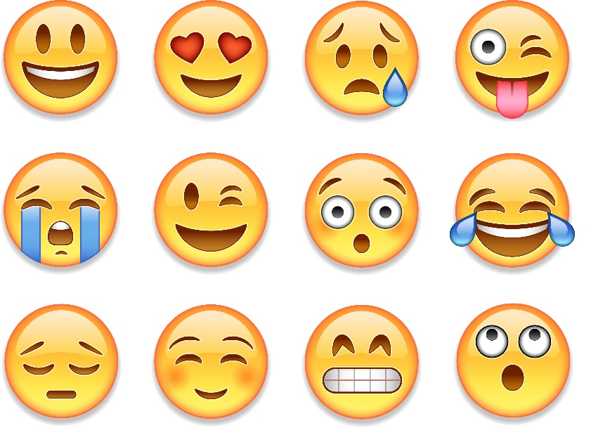

Learning Target: ___________________________________
_________________________________________________
Demonstration:

Exit Slip
Date: _______________
Name:
Learning Target: ______________________________
______________________________
______________________________
Did Not Need More Got It!
Get It Yet Practice
Why? _____________________
__________________________
__________________________

Demonstrate:

If students check the boxes: Did Not Get It Yet or Need More Practice, they need to explain why in the lines below it. Here are some great phrases to guide their response:
- I don’t understand how to…
- I don’t understand the word…
- I don’t understand how ____________ is related to _________________.
- I don’t understand how ____________ caused __________________________________.
- My question is…
- I need you to show me…
- I need more practice with…

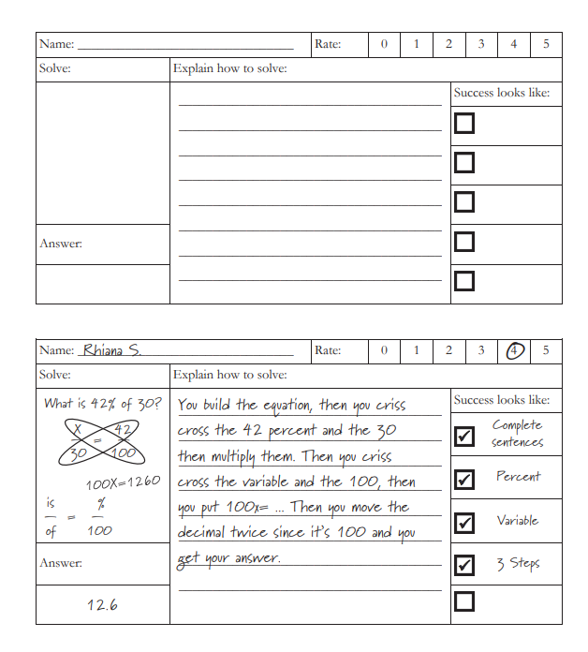
Math Exit Ticket with Writing Proof of Thinking
Thanks to: Riverton Middle School Math Teachers

Weekly Target Practice
Student Self-Assessment (K-3)
Name: ______________________________Subject: __________________________________ Unit: ___________________
Target | Comments
Monday Target: _________________________________  _________________________________ | Why did you place the “X” in that particular location?  Demonstrate:
Tuesday Target: _________________________________  _________________________________ | Why did you place the “X” in that particular location?  Demonstrate:
Wednesday Target: _________________________________  _________________________________ | Why did you place the “X” in that particular location?  Demonstrate:

Thursday Target: _________________________________  _________________________________ | Why did you place the “X” in that particular location?  Demonstrate:
Friday Target: _________________________________  _________________________________ | Why did you place the “X” in that particular location?  Demonstrate:

Conference with teacher notes (goals for weekend review/next week):

My Progress Learning Graph (K-3)
My name: ____________________________________
Subject Area: ____________________________
Got It!
More Practice
Approaching

Not Yet

Outcomes & Date

________________’s Learning Target Tracker
If students check the boxes: Did Not Get It Yet or Need More Practice, they need to explain why in the lines below it. Here are some great phrases to guide their response:
- I don’t understand how to…
- I don’t understand the word…
- I don’t understand how ____________ is related to _________________.
- I don’t understand how ____________ caused __________________________________.
- My question is…
- I need you to show me…
- I need more practice with…

Unit: __________________________ Dates: ________________
“I Can” Target | Not There Yet | Still Practicing | Got It! | Comments
1.

2.

3.

4.

5.

- Potential Comments - I need more practice or Not There Yet Stems:
- I don’t understand how to…
- I don’t understand the word…
- I don’t understand how ____________ is related to _________________.
- I don’t understand how ____________ caused __________________________________.
- My question is…
- I need you to show me…
- I need more practice with…

